Angela's Tools · Chapter 29: Engineering Solutions for Protecting Ecosystems · Worksheet 1 of 10

Two Graphs, Two Stories: Wild Cycles and a Rising Line (Teacher answer key)
Learning target: I can describe how lynx and snowshoe hare numbers rise and fall in repeating cycles while the human population keeps climbing, and write a first explanation of why the patterns differ and what that means for ecosystems.
Phenomenon exploration · about 30 minutes · individual · Standards: MS-LS2-5 (supports), MS-ESS3-4 (supports), MS-LS2-1 (supports)

Standards connections
MS-LS2-5 (supports): This sheet raises the question that drives the chapter: if people keep asking more of ecosystems, which designs can protect biodiversity and ecosystem services? Students do not evaluate any solution yet.
MS-ESS3-4 (supports): Students read real United Nations population milestones, the kind of evidence the Grade 8 PE uses. In California this is a Grade 8 performance expectation; here it is background only, and no argument about Earth's systems is assessed.
MS-LS2-1 (supports): Part C asks students to recall from earlier Grade 7 lessons how food and predators limit a wild population. That prior idea is what makes the hare and lynx cycle a useful contrast with people.

Answers with reasoning

Observation 1: What the fur traders wrote down
In the snowy forests of Canada and Alaska, the Canada lynx, a short-tailed wild cat, depends heavily on one prey animal: the snowshoe hare. For more than a century, fur-trading posts, especially those of the Hudson's Bay Company, kept careful books of how many pelts (skins) trappers brought in each year. When ecologists graphed those books in the first half of the 1900s, they found that both animals rose and fell in a rhythm that repeated roughly every ten years. The graph below copies the shape of that pattern with invented numbers so you can study it.
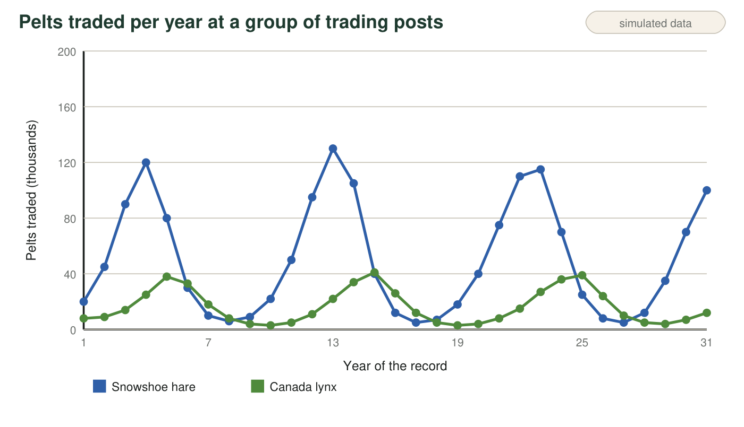
Teaching dataset. The numbers are invented to match the shape of the real fur-trade records (a cycle of about ten years, with lynx peaks a little after hare peaks). They are not the actual counts. A pelt count is a count of animals trapped, not of all animals alive.

Observation 2: People on the same planet
People are animals too, and we also depend on food, water and space. The table shows the years when the world's human population passed each billion. These are real estimates made by population scientists at the United Nations.
When the world population passed each billion
World population | Year reached
1 billion | about 1804
2 billion | 1927
3 billion | 1960
4 billion | 1974
5 billion | 1987
6 billion | 1999
7 billion | 2011
8 billion | 2022
about 8.2 billion | 2025 (estimate)

Real estimates. Milestone years are United Nations estimates; the 1804 date is the least certain because there were no worldwide counts then. The 2025 figure is the UN Population Fund's estimate for that year (about 8,232 million people).

Part A: Notice and wonder
1. Write three things you notice about the hare and lynx graph. At least one must compare the timing of the two lines.
Answer: Examples: both lines go up and down over and over; the hare line has three high peaks (near years 4, 13 and 23); the lynx line peaks about one or two years after each hare peak; hare numbers are always higher than lynx numbers; the hare line swings from about 5 to 130 thousand, much more than the lynx line; the lows also come in a repeating pattern.
Reasoning: Any accurate observation of the graph counts. The timing comparison (lynx peaks after hare peaks) is the key notice for the chapter.
Also acceptable: Accept 'the lynx follows the hare' or 'the lynx is a bit behind' as the timing notice.
Full credit must include:
• Three observations drawn from the graph
• At least one compares the timing of the two lines
• Observations, not explanations
2. Write two things you notice about the population table. At least one must use numbers from the table.
Answer: Examples: it took about 123 years to go from 1 to 2 billion but only 11 to 13 years for each billion since 1974; the population has never gone down in the table; it went from 4 billion in 1974 to about 8.2 billion in 2025, roughly doubling in about 50 years; after 1974 the gaps between billions stopped shrinking much and stayed between 11 and 13 years.
Reasoning: Students should read numbers from the table. The observation that recent gaps stay about the same (11-13 years) is a sharp notice that the chapter uses later: the total is still rising, but the percentage growth rate has fallen.
Also acceptable: Accept 'it keeps going up faster' as an initial notice; W5 refines it.
Full credit must include:
• Two accurate observations
• At least one uses numbers from the table
3. Write three questions you wonder about after studying both observations. Start each with why, how or what would happen if.
Answer: Examples: Why do lynx peak after hares? What makes the hare population crash? What would happen to the lynx if hares disappeared? How long can the human population keep growing? How do more people change forests and oceans? Why do people not cycle like hares?
Reasoning: Questions should come from the two observations and be answerable with evidence or investigation.
Also acceptable: Questions about the data themselves ('How did they count the hares?') are good science questions and earn credit.
Full credit must include:
• Three questions
• Each starts with why, how or what would happen if
• Each connects to one of the observations

Part B: A few numbers
4. How many years did the world take to grow from 1 billion to 2 billion people? How many years from 7 billion to 8 billion? About how many times longer was the first jump? Show your subtraction and division.
Answer: 1 to 2 billion: 1927 − 1804 = 123 years. 7 to 8 billion: 2022 − 2011 = 11 years. 123 ÷ 11 ≈ 11.2, so the first jump took about 11 times longer.
Reasoning: The comparison shows how much faster the population added people in recent decades than in the 1800s.
Also acceptable: Accept 'about 11 times' or 'more than 10 times'. If a student uses 'about 1800' from memory, 127 ÷ 11 ≈ 11.5 also earns credit.
5. Use the graph to estimate the years when the hare line reaches its three highest points. About how many years pass from one hare peak to the next?
Answer: Hare peaks near years 4, 13 and 23. Gaps: 13 − 4 = 9 years and 23 − 13 = 10 years, so about 9 to 10 years between peaks.
Reasoning: Reading peaks from a printed graph is approximate; the point is a repeating cycle of roughly ten years, which matches the real fur records.
Also acceptable: Accept any estimate from 8 to 11 years if the peaks chosen are the three high points.

Part C: What you already know
6. From earlier lessons on populations: name two things that could make a hare population shrink and two things that could make a lynx population shrink.
Answer: Hares: running out of food (twigs and bark in winter), being eaten by predators such as lynx, coyotes and owls, disease or parasites, harsh weather. Lynx: too few hares to eat, starvation, trapping by people, disease.
Reasoning: This recalls limiting factors from earlier lessons on resources and interactions; both food supply and predation will reappear in W5 and W7.
Also acceptable: Accept 'habitat loss' and 'hunting by people' as limits.
Full credit must include:
• Two limits for hares
• Two limits for lynx
• At least one food-related limit and one predator- or prey-related limit

Part D: Your first explanation
7. Why might the lynx line peak a year or two after the hare line instead of at the same time? Give your best explanation and one reason for it.
Answer: When hares are plentiful, lynx eat well, survive and raise more kittens, so the lynx population keeps growing for a while. It takes time for lynx to be born and grow up, so their numbers peak after the hares have already peaked. When hares crash, lynx are left with too little food, so lynx numbers fall a year or two later.
Reasoning: The lag comes from the time it takes predators to respond through births and deaths. This is a hypothesis students will test against experiment results in W5 and W7.
Also acceptable: Partial credit for 'the lynx eat the hares and then run out of food' without explaining the delay. Accept answers that also mention trappers following the animals.
Full credit must include:
• Links lynx success to hare abundance
• Explains a delay (time to reproduce, grow or starve)
• Gives a reason
8. The hare line goes up and then crashes, but the human line has kept climbing for two hundred years. What have people done that hares cannot do? Name at least two things and explain how each lets a population keep growing.
Answer: People grow their own food through farming, so food supply grew with the population; medicine, vaccines, clean water and sewage systems lowered death rates; people store food and trade it across the world, so a local shortage does not cause a crash; people have no major predator; fossil fuels and machines let people take more resources from ecosystems.
Reasoning: Hares are limited by local food and predators; people have expanded their food supply and reduced deaths. The cost is that people draw more and more from ecosystems, which is the chapter's focus.
Also acceptable: Accept 'people build houses and hospitals' if the student explains how it lowers deaths. Do not accept 'people are smarter' without a mechanism.
Full credit must include:
• At least two human abilities that hares lack
• Each linked to more births surviving, fewer deaths, or more resources
9. Every person needs water, food, energy and materials that come from ecosystems. Predict one thing that could happen to forests, rivers or oceans if there are more people and each person uses more. Then write one question an engineer would need answered before designing a way to protect that ecosystem.
Answer: Example prediction: more forests would be cut for farms and wood, so forest animals lose habitat. Example question: How much forest does each family's farm need, and can the same food be grown on less land?
Reasoning: This previews the six pressures (over-exploitation, pollution, emerging disease, habitat degradation, invasive species, climate change) and the idea that an engineer must define the problem before designing.
Also acceptable: Any reasonable pressure (overfishing, pollution, water shortages) earns credit if linked to population and use per person.
Full credit must include:
• A prediction tied to more people and more use per person
• A question that would help define criteria or constraints for a solution
Keep this page
At the end of the chapter you will reread q7, q8 and q9 and mark what you would keep, change or add. Changing a first explanation because of new evidence is how science works.

Teacher notes
The hare and lynx graph is simulated and labeled so; it copies the real pattern from Hudson's Bay Company records (a cycle of about ten years, lynx peaks lagging hare peaks by about one to two years). The human table is real (UN milestone estimates; UNFPA 2025 estimate of 8,232 million). The textbook calls the hare a 'rabbit'; it is a hare, a close relative, and it is the snowshoe hare that cycles. Expect q7 answers to treat the lag as proof that lynx cause the cycle; leave that for now and return to it in W5 (experiment results) and W7. Some students will say the human population is 'growing faster and faster'. The table shows each recent billion took about 12 years; the total still rises but the percentage growth rate has fallen since the 1960s. Collect the sheets or have students keep them for the end-of-chapter revisit.

