Angela's Tools · Chapter 29: Engineering Solutions for Protecting Ecosystems · Worksheet 1 of 10

Two Graphs, Two Stories: Wild Cycles and a Rising Line
Learning target: I can describe how lynx and snowshoe hare numbers rise and fall in repeating cycles while the human population keeps climbing, and write a first explanation of why the patterns differ and what that means for ecosystems.
Phenomenon exploration · about 30 minutes · individual · Standards: MS-LS2-5 (supports), MS-ESS3-4 (supports), MS-LS2-1 (supports)
Name: ____________________________ Date: ____________ Period: ______

Directions
Read both observations. Study the graph and the table before you write anything. The graph is a teaching version of a real pattern; the table holds real estimates. In Part A, write what you notice before what you wonder. Part D asks for a first explanation: it is fine to be unsure, but give a reason for every idea. Keep this sheet; you will revise Part D at the end of the chapter.

Observation 1: What the fur traders wrote down
In the snowy forests of Canada and Alaska, the Canada lynx, a short-tailed wild cat, depends heavily on one prey animal: the snowshoe hare. For more than a century, fur-trading posts, especially those of the Hudson's Bay Company, kept careful books of how many pelts (skins) trappers brought in each year. When ecologists graphed those books in the first half of the 1900s, they found that both animals rose and fell in a rhythm that repeated roughly every ten years. The graph below copies the shape of that pattern with invented numbers so you can study it.
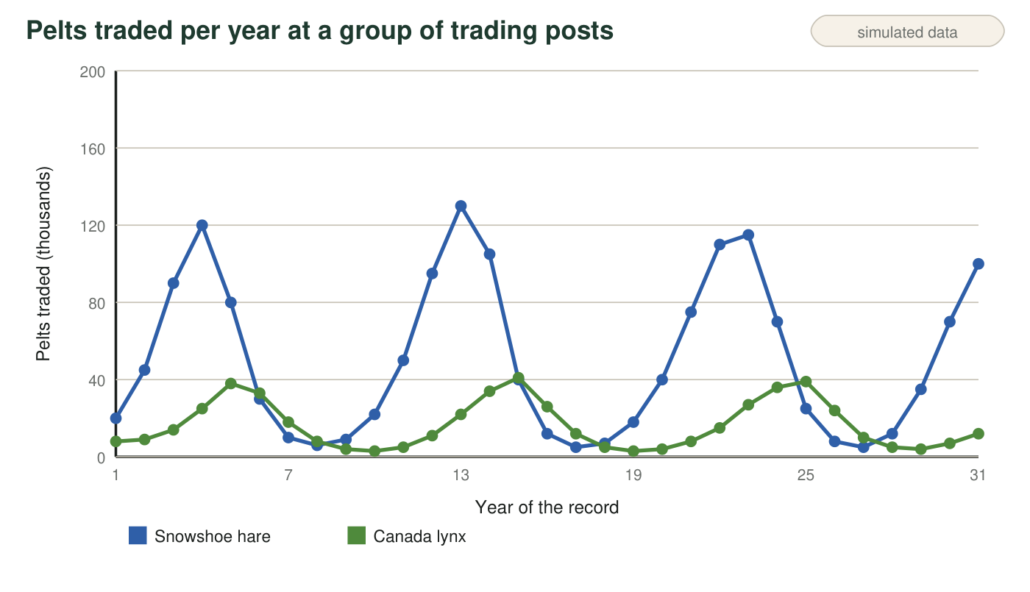
Teaching dataset. The numbers are invented to match the shape of the real fur-trade records (a cycle of about ten years, with lynx peaks a little after hare peaks). They are not the actual counts. A pelt count is a count of animals trapped, not of all animals alive.

Observation 2: People on the same planet
People are animals too, and we also depend on food, water and space. The table shows the years when the world's human population passed each billion. These are real estimates made by population scientists at the United Nations.
When the world population passed each billion
World population | Year reached
1 billion | about 1804
2 billion | 1927
3 billion | 1960
4 billion | 1974
5 billion | 1987
6 billion | 1999
7 billion | 2011
8 billion | 2022
about 8.2 billion | 2025 (estimate)

Real estimates. Milestone years are United Nations estimates; the 1804 date is the least certain because there were no worldwide counts then. The 2025 figure is the UN Population Fund's estimate for that year (about 8,232 million people).

Part A: Notice and wonder
1. Write three things you notice about the hare and lynx graph. At least one must compare the timing of the two lines.
______________________________________________________________________________________
______________________________________________________________________________________
______________________________________________________________________________________
2. Write two things you notice about the population table. At least one must use numbers from the table.
______________________________________________________________________________________
______________________________________________________________________________________
______________________________________________________________________________________
3. Write three questions you wonder about after studying both observations. Start each with why, how or what would happen if.
______________________________________________________________________________________
______________________________________________________________________________________
______________________________________________________________________________________

Part B: A few numbers
4. How many years did the world take to grow from 1 billion to 2 billion people? How many years from 7 billion to 8 billion? About how many times longer was the first jump? Show your subtraction and division.
______________________________________________________________________________________
______________________________________________________________________________________
______________________________________________________________________________________
5. Use the graph to estimate the years when the hare line reaches its three highest points. About how many years pass from one hare peak to the next?
______________________________________________________________________________________
______________________________________________________________________________________

Part C: What you already know
6. From earlier lessons on populations: name two things that could make a hare population shrink and two things that could make a lynx population shrink.
______________________________________________________________________________________
______________________________________________________________________________________
______________________________________________________________________________________
______________________________________________________________________________________

Part D: Your first explanation
7. Why might the lynx line peak a year or two after the hare line instead of at the same time? Give your best explanation and one reason for it.
______________________________________________________________________________________
______________________________________________________________________________________
______________________________________________________________________________________
______________________________________________________________________________________
______________________________________________________________________________________
______________________________________________________________________________________
8. The hare line goes up and then crashes, but the human line has kept climbing for two hundred years. What have people done that hares cannot do? Name at least two things and explain how each lets a population keep growing.
______________________________________________________________________________________
______________________________________________________________________________________
______________________________________________________________________________________
______________________________________________________________________________________
______________________________________________________________________________________
______________________________________________________________________________________
9. Every person needs water, food, energy and materials that come from ecosystems. Predict one thing that could happen to forests, rivers or oceans if there are more people and each person uses more. Then write one question an engineer would need answered before designing a way to protect that ecosystem.
______________________________________________________________________________________
______________________________________________________________________________________
______________________________________________________________________________________
______________________________________________________________________________________
Keep this page
At the end of the chapter you will reread q7, q8 and q9 and mark what you would keep, change or add. Changing a first explanation because of new evidence is how science works.

Reading the graph one step at a time
Put your finger on the hare line and slide it right. Each time the line stops climbing and starts to fall, write the year under the graph. Do the same for the lynx line in a different color. Then compare your two lists: which animal's peak comes first? For q8, finish this starter: 'Hares cannot ___, but people can ___, so ___.'

How good is a fur record as a census?
A pelt count depends on how many trappers were working, how hard they tried and what furs were worth that year. Write a short paragraph describing two ways the fur records could be misleading about the real number of animals, and propose one modern method ecologists could use instead to count hares (for example, live-trapping and marking animals, or counting droppings in fixed plots). Explain why your method gives better evidence.

