Angela's Tools · Chapter 29: Engineering Solutions for Protecting Ecosystems · Worksheet 4 of 10

Modeling the Sound: Nitrogen, Oxygen and a Test-and-Revise Loop (Teacher answer key)
Learning target: I can interpret a cause-and-effect model of nitrogen pollution in Long Island Sound and extend it to show where a solution acts, how it is measured, and how the solution is revised.
Diagrams and models · about 40 minutes · individual · Standards: MS-LS2-5 (practice), MS-ETS1-2 (practice)

Standards connections
MS-LS2-5 (practice): Students use a model to explain how a design solution (removing nitrogen at sewage plants) protects an ecosystem service (oxygen-rich water that supports seafood) and compare it with competing solutions. The full evaluation of competing designs is assessed in W6 and W9.
MS-ETS1-2 (practice): The healthy-ecosystem model acts as a set of criteria; students compare measurements against it and use real monitoring data to judge how well a solution is working, which practices systematic evaluation.

Answers with reasoning
Long Island Sound lies between Connecticut and Long Island, New York, and millions of people live along its shores. For decades, scientists found that each summer large areas of its bottom water held too little oxygen for lobsters, fish and oysters. They built a model of what a healthy Sound should look like and compared their measurements with it.
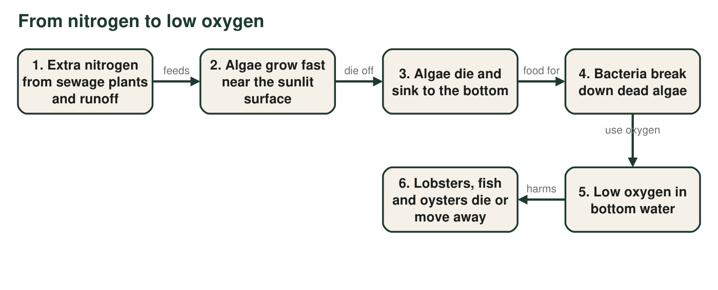
Figure 1. How extra nitrogen leads to low oxygen in bottom water. Algae near the surface release oxygen when they photosynthesize; the oxygen problem comes later, when bacteria break down the dead algae near the bottom.
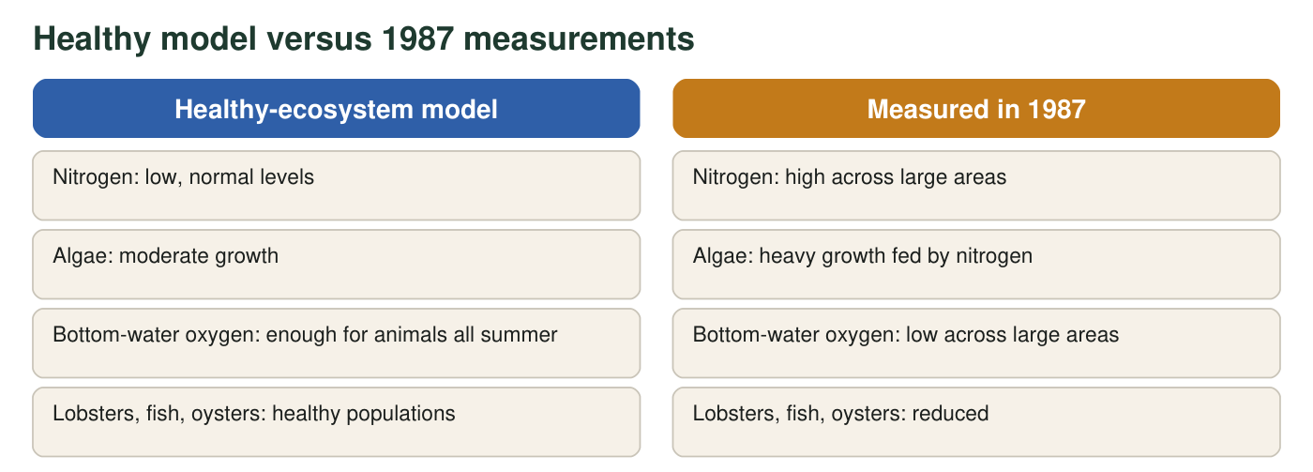
Figure 2. The healthy-ecosystem model compared with summer measurements from 1987, when the problem was first measured across the Sound. Descriptions are simplified.
Area of low-oxygen (hypoxic) bottom water in Long Island Sound
Period | Average area of low-oxygen bottom water (square miles)
1987-1999 (before nitrogen limits took full effect) | 208
2021-2025 | 83

Real values from the Long Island Sound Partnership. The averages smooth out year-to-year changes caused by weather. Wastewater plants around the Sound were upgraded to remove nitrogen after the 1990s limits.

Part A: Read the model
1. According to Figure 1, which living things use up most of the oxygen in the bottom water?
Answer: B. Bacteria, while decomposing dead algae.
Reasoning: Box 4 to box 5: decomposers use oxygen as they break down the large mass of dead algae. Photosynthesis by living algae adds oxygen, mostly to surface water.
Also acceptable: None.
2. A classmate writes: 'Algae take oxygen out of the water when they photosynthesize.' Use Figure 1 and what you know about photosynthesis to correct this sentence.
Answer: Algae release oxygen when they photosynthesize. The oxygen loss comes later, when the algae die and sink and bacteria use up oxygen as they decompose them (and as all living things respire).
Reasoning: This corrects an error in the textbook (p. 398), which says producers extract oxygen during photosynthesis.
Also acceptable: Accept mention that algae also use some oxygen in respiration at night, as long as photosynthesis is described as releasing oxygen.
Full credit must include:
• States that photosynthesis releases oxygen
• Identifies decomposition by bacteria as the main oxygen drain
3. Low oxygen is worst in the bottom water in late summer. Use boxes 3 and 4 to explain why the bottom is affected, and suggest why oxygen from the surface does not easily reach the bottom when the surface water is warm.
Answer: The dead algae sink and pile up near the bottom, so that is where the bacteria do most of their decomposing and use up oxygen. In summer, warm surface water is lighter and floats on top of cooler, saltier bottom water, so the layers do not mix well and oxygen from the air and from surface algae does not get mixed down to replace what bacteria use.
Reasoning: Hypoxia in the Sound is a bottom-water problem caused by decomposition below a layered water column; mixing is weakest in late summer.
Also acceptable: Accept 'the bottom is far from the air and the sunlight' as a partial answer if decomposition is named.
Full credit must include:
• Links sinking dead algae to decomposition at the bottom
• Explains that layering or poor mixing keeps surface oxygen from reaching the bottom
4. Figure 2: which two measurements told scientists the Sound did not match the healthy model? Why did they decide to cut nitrogen (box 1) instead of trying to add oxygen to the water (box 5)?
Answer: Nitrogen was high and bottom-water oxygen was low across large areas (reduced wildlife and heavy algae growth also differed from the model). Scientists cut nitrogen because it is the cause at the start of the chain: removing it stops the extra algae, so less dead algae reach the bottom. Adding oxygen to a whole sound would be enormously expensive and would treat only the symptom, so the problem would return.
Reasoning: The model shows nitrogen as the root cause; acting early in a cause-and-effect chain fixes the problem rather than one effect.
Also acceptable: Accept 'the biggest source of nitrogen was sewage plants, which can be upgraded' as the reason.
Full credit must include:
• Names nitrogen and oxygen as the mismatched measurements
• Explains that nitrogen is the root cause
• Gives a cost or practicality reason against adding oxygen
5. Use the table. By what percent did the average area of low-oxygen water shrink from 1987-1999 to 2021-2025? Show your calculation.
Answer: Decrease = 208 − 83 = 125 square miles. Percent decrease = 125 ÷ 208 × 100 ≈ 60%.
Reasoning: The Long Island Sound Partnership reports this as about a 60 percent reduction.
Also acceptable: Accept 60.1% or 'about 60%'.
6. Does the table alone prove that the nitrogen limits caused the improvement? Name one more piece of evidence that would make the claim stronger.
Answer: No. The two averages show the problem shrank, but weather and other changes could also matter. Stronger evidence: measurements showing nitrogen in the water fell at the same time; records showing nitrogen released by the sewage plants dropped; hypoxia staying lower across many years with different weather; comparing areas near upgraded plants with areas farther away.
Reasoning: A before-and-after comparison supports but does not prove a cause; matching nitrogen data and consistency across years strengthen it.
Also acceptable: Accept 'measure oxygen every year, not just averages' if linked to ruling out weather.
Full credit must include:
• Says the table alone is not proof
• Names one specific additional piece of evidence
7. Label the model. For each row, write the box or arrow from Figure 1 and explain your choice.
Answer: Sewage-plant upgrades act at box 1 (they lower the nitrogen entering the water, weakening the arrow from box 1 to box 2). Decomposers carry out box 4 (bacteria decompose dead algae). Dissolved oxygen is measured at box 5 (water samples or sensors at different depths, especially near the bottom). Seafood depends on box 6 (lobster, fish and oyster populations), which depends on box 5 being healthy.
Reasoning: Labeling checks that students can map the real-world actions and measurements onto the model.
Also acceptable: For the last row, accept box 5 (oxygen-rich water) with the reason that it is what the animals need.
Full credit must include:
• Correct box or arrow for at least three of four rows
• A reason for each

Part B: Build and extend the model
Redraw the six-box chain from Figure 1. Then: (1) add a solution box, 'Sewage plants remove nitrogen', with an arrow showing which box it acts on, and cross out or thin the arrow it weakens; (2) next to at least three boxes, write the measurement scientists would take to check that step; (3) draw a feedback loop: measure → compare with the healthy model → modify the solution → measure again; (4) add one box for a cause the nitrogen plan cannot control, and draw an arrow to the box it affects.
Expected drawing: A chain of six boxes. A solution box ('Sewage plants remove nitrogen') points at box 1, and the arrow from box 1 to box 2 is thinned or crossed. Measurements labeled next to at least three boxes, for example: nitrogen in water samples (box 1), algae or chlorophyll in surface water (box 2), dissolved oxygen at the bottom (box 5), trawl counts of lobsters and fish (box 6). A feedback loop: measure → compare with the healthy model → modify the solution (for example, tighter limits or also cut fertilizer runoff) → measure again. An extra box for an uncontrolled cause, such as 'warmer water', with an arrow to box 6 (and possibly box 5, since warm water holds less oxygen).
Reasoning: The drawing must show where the solution acts, how each step is tested, and the iterative loop of testing and revising.
8. By 2016 many fish had recovered, but lobsters had not come back as much as hoped. Name the cause you added in step (4) of your drawing and explain how it could hold lobsters back even when oxygen improves.
Answer: Example: warmer water. Lobsters are stressed by warm water, which can make them more likely to get sick and push them toward cooler water offshore, and warm water also holds less oxygen. So lobsters can stay low even after the nitrogen plan improves oxygen.
Reasoning: NOAA Fisheries attributes the southern New England lobster decline to a combination of warmer water, low oxygen and other stresses. A model that leaves out a cause can make a working solution look like a failure.
Also acceptable: Accept disease or continued fishing pressure with a mechanism.
Full credit must include:
• Names a cause outside the nitrogen chain
• Explains how it affects lobsters independently of nitrogen
9. Here are two competing solutions that also target nitrogen: (A) restore salt marshes along the shore, where microbes remove nitrogen from water flowing through; (B) pay homeowners and farms to use less fertilizer. For one of them, say which box or arrow of the model it acts on and name one tradeoff or limit.
Answer: (A) Salt marshes act between box 1 and box 2: microbes in marsh soil remove some nitrogen before it reaches open water. Tradeoff or limit: needs shoreline land that may already be developed, takes years to work, and handles runoff better than piped sewage. (B) Less fertilizer acts at box 1 by lowering nitrogen in runoff. Tradeoff or limit: it costs money for payments, depends on many people changing habits, and is hard to check.
Reasoning: Both are real nitrogen-reduction strategies; each acts early in the chain but with different costs and limits, which is the competing-solutions idea of MS-LS2-5.
Also acceptable: Accept that marshes also provide habitat and flood protection as an added benefit if a limit is also named.
Full credit must include:
• Places the solution at the correct point in the model
• Names a realistic tradeoff or limit

Teacher notes
The textbook (p. 398) says algae extract oxygen during photosynthesis; that is backward, and Figure 1 and q2 teach the correct mechanism. Hypoxia in Long Island Sound is a summer bottom-water problem: warm surface water floats on cooler, saltier water, and bacteria decomposing sunken algae use up oxygen below. The table values come from the Long Island Sound Partnership hypoxia indicator (1987-1999 average 208 square miles; 2021-2025 average 83; about 60 percent smaller). The 1987 and 2016 points in the prompts come from the lesson. Lobster recovery has also been limited by warmer water (NOAA Fisheries), so q8 expects students to see a model's boundary, not a failed solution.

