Angela's Tools · Chapter 29: Engineering Solutions for Protecting Ecosystems · Worksheet 4 of 10

Modeling the Sound: Nitrogen, Oxygen and a Test-and-Revise Loop
Learning target: I can interpret a cause-and-effect model of nitrogen pollution in Long Island Sound and extend it to show where a solution acts, how it is measured, and how the solution is revised.
Diagrams and models · about 40 minutes · individual · Standards: MS-LS2-5 (practice), MS-ETS1-2 (practice)
Name: ____________________________ Date: ____________ Period: ______

Directions
Study Figure 1 box by box, reading each arrow as 'leads to'. Then compare the two columns in Figure 2 and read the table of real measurements. Answer Part A, then build your own model in Part B. Use a pencil so you can revise your drawing.
Long Island Sound lies between Connecticut and Long Island, New York, and millions of people live along its shores. For decades, scientists found that each summer large areas of its bottom water held too little oxygen for lobsters, fish and oysters. They built a model of what a healthy Sound should look like and compared their measurements with it.
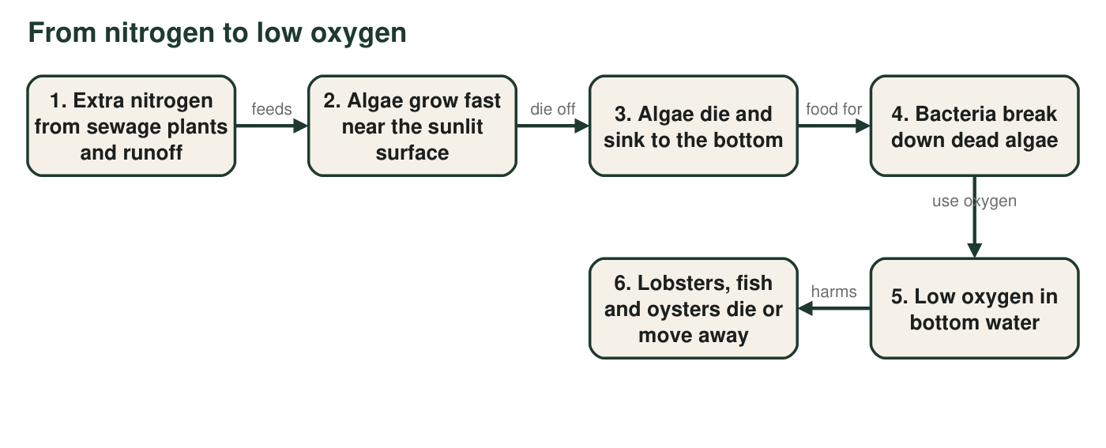
Figure 1. How extra nitrogen leads to low oxygen in bottom water. Algae near the surface release oxygen when they photosynthesize; the oxygen problem comes later, when bacteria break down the dead algae near the bottom.
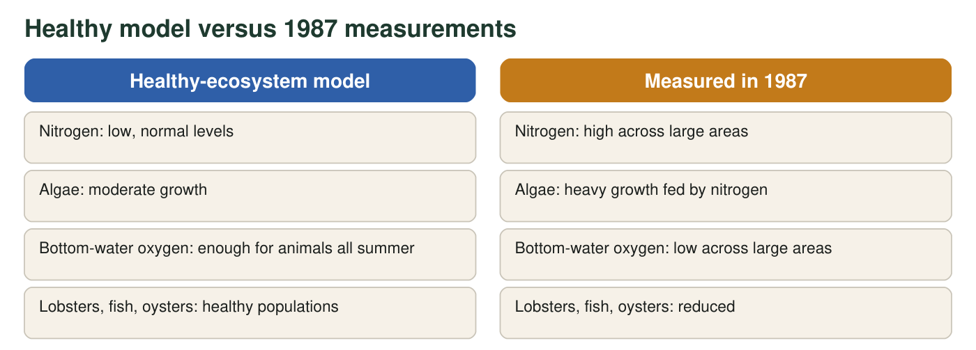
Figure 2. The healthy-ecosystem model compared with summer measurements from 1987, when the problem was first measured across the Sound. Descriptions are simplified.
Area of low-oxygen (hypoxic) bottom water in Long Island Sound
Period | Average area of low-oxygen bottom water (square miles)
1987-1999 (before nitrogen limits took full effect) | 208
2021-2025 | 83

Real values from the Long Island Sound Partnership. The averages smooth out year-to-year changes caused by weather. Wastewater plants around the Sound were upgraded to remove nitrogen after the 1990s limits.

Part A: Read the model
1. According to Figure 1, which living things use up most of the oxygen in the bottom water?
○ A. Algae, during photosynthesis
○ B. Bacteria, while decomposing dead algae
○ C. Lobsters, while they hunt
○ D. Fish swimming near the surface
2. A classmate writes: 'Algae take oxygen out of the water when they photosynthesize.' Use Figure 1 and what you know about photosynthesis to correct this sentence.
______________________________________________________________________________________
______________________________________________________________________________________
______________________________________________________________________________________
3. Low oxygen is worst in the bottom water in late summer. Use boxes 3 and 4 to explain why the bottom is affected, and suggest why oxygen from the surface does not easily reach the bottom when the surface water is warm.
______________________________________________________________________________________
______________________________________________________________________________________
______________________________________________________________________________________
4. Figure 2: which two measurements told scientists the Sound did not match the healthy model? Why did they decide to cut nitrogen (box 1) instead of trying to add oxygen to the water (box 5)?
______________________________________________________________________________________
______________________________________________________________________________________
______________________________________________________________________________________
5. Use the table. By what percent did the average area of low-oxygen water shrink from 1987-1999 to 2021-2025? Show your calculation.
______________________________________________________________________________________
______________________________________________________________________________________
______________________________________________________________________________________
6. Does the table alone prove that the nitrogen limits caused the improvement? Name one more piece of evidence that would make the claim stronger.
______________________________________________________________________________________
______________________________________________________________________________________
______________________________________________________________________________________
7. Label the model. For each row, write the box or arrow from Figure 1 and explain your choice.
Box or arrow | Why
Where the sewage-plant upgrades act
The step carried out by decomposers
Where scientists measure dissolved oxygen
The step that ecosystem services such as seafood depend on

Part B: Build and extend the model
Redraw the six-box chain from Figure 1. Then: (1) add a solution box, 'Sewage plants remove nitrogen', with an arrow showing which box it acts on, and cross out or thin the arrow it weakens; (2) next to at least three boxes, write the measurement scientists would take to check that step; (3) draw a feedback loop: measure → compare with the healthy model → modify the solution → measure again; (4) add one box for a cause the nitrogen plan cannot control, and draw an arrow to the box it affects.

8. By 2016 many fish had recovered, but lobsters had not come back as much as hoped. Name the cause you added in step (4) of your drawing and explain how it could hold lobsters back even when oxygen improves.
______________________________________________________________________________________
______________________________________________________________________________________
______________________________________________________________________________________
9. Here are two competing solutions that also target nitrogen: (A) restore salt marshes along the shore, where microbes remove nitrogen from water flowing through; (B) pay homeowners and farms to use less fertilizer. For one of them, say which box or arrow of the model it acts on and name one tradeoff or limit.
______________________________________________________________________________________
______________________________________________________________________________________
______________________________________________________________________________________
______________________________________________________________________________________

Read the arrows aloud
Read Figure 1 as a sentence: 'Extra nitrogen feeds algae, so algae grow fast; the blooms crash, so dead algae sink; the dead algae are food for bacteria, so ...'. Finish the sentence before you answer Part A. For the drawing, start with the six boxes in a line, then add one new piece at a time, checking it off in the prompt as you go.

Why weather matters
The hypoxic area changes from year to year even when nitrogen stays about the same. Hot, calm summers make it worse; windy weather that mixes the water makes it better. Write a paragraph explaining why scientists use multi-year averages to judge the nitrogen plan, and predict how warmer summers caused by climate change could make the target harder to reach. Suggest one change to the monitoring plan that would help separate the effect of weather from the effect of the solution.

